Name: ___________________________________ Class Period _______
Matter and Atoms Study Guide
States of Matter:
Solid Liquid Gas

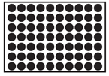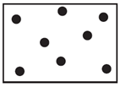

Particles are close together Particles have space to move Particles are far apart

Low Kinetic Energy Moderate Kinetic Energy High amount of Kinetic Energy
[particles vibrate] [particles move and bounce off [particles are far apart]
Of each other]

Definite volume Definite volume No volume

Definite shape Takes the shape of its container No shape

Mass: how much matter something contains. We commonly think of this as weight [but remember weight is the measure of gravitational force on an object].
Ways to measure this: triple beam balance, scale, etc
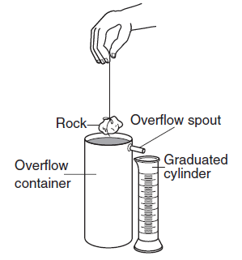
Units: grams

Volume: a measure of the amount of space something takes up.
Ways to measure this: measuring cups for liquid volume, length x width x height calculations for regularly shaped solids, water displacement in a graduated cylinder for irregularly shaped solids [see picture to right for clarification on water displacement]
Units: mL or cm³

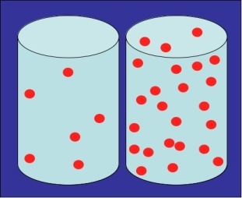
Density: comparing Mass and Volume. This measure tells you how tightly atoms are packed into a certain amount of space.
Ways to measure this: mass/volume calculations
Units: g/cm³

*** things that are less dense will float on top of things that are more dense

The Law of Conservation: the mass you end with is the same as the mass that you begin with
Ex 1) If you chemically change a log by burning it, the mass of the log and the mass of the ash remains the same

Chemical Change Physical Change

When you create a brand new substance When you change aspects of the substance
without creating something new

Ex) burning wood Ex) changing the state
Wood ash H₂O Water ice
These two substances are made up of Liquid solid
Different elements

Ex) rust and oxidation Ex) Crushing rocks

The Periodic Table: a model used to determine the properties of elements

This is arranged in rows which are called periods. These organize elements based on energy level. Each row corresponds to the number of electron shells each element organizes its electrons in.

The columns are called groups. Groups identify elements that have similar properties based on their structure.

Metals Nonmetals Metalloids

Shiny Dull Shiny or dull

Malleable [can bend] Brittle [break if bended] Malleable [can bend]

Ductile [can be made into wire] Not Ductile [Can’t be wire] Ductile [can be made into wire]

Best conductor of heat Bad conductor of heat Ok conductor of heat

Best conductor of electricity Bad conductor of electricity Ok conductor of electricity

Often a solid Often a gas Often a solid

Mixtures Elements and Compounds

The physical combination of 2 or more The chemical joining of two or more elements
substances. to create a new substance

Heterogeneous – least mixed Written with two or more capital letters

Can be separated using physical means Can only be separated chemically
Ex) evaporation of water to leave A reaction must occur to break the
other materials behind bond that holds the molecule together
Coffee filters
Using a magnet

